
Sri Lanka Institute of Information Technology

IT2130 – Operating Systems and System Administration
Year 2, Semester 2- 2026

Practical Answer Submission

Practical Sheet No: 09

Student ID | IT24102099
Student Name | Mathuppriya Naguleswaran
Campus/ Center name | SLIIT – Northen UNI
Specialization | Software Engineering
Batch No | 1

Unix/Linux file management
Activity 1 — Unix Directory Structure
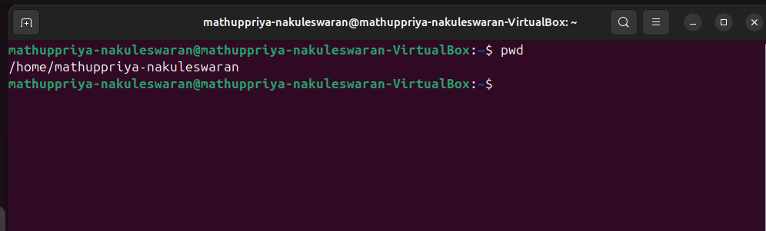
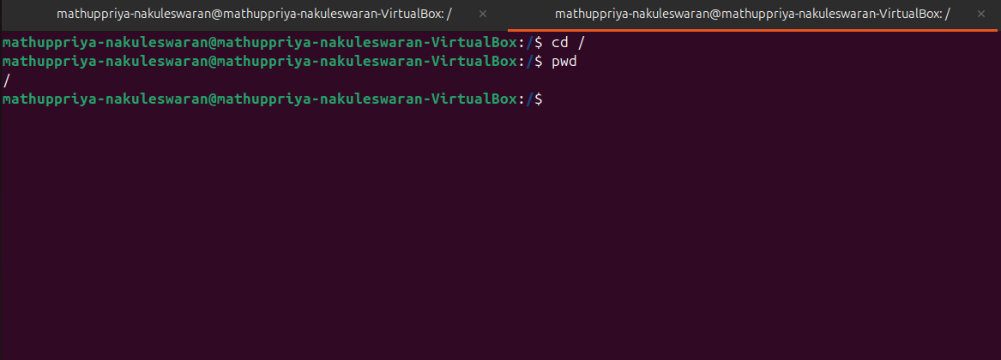
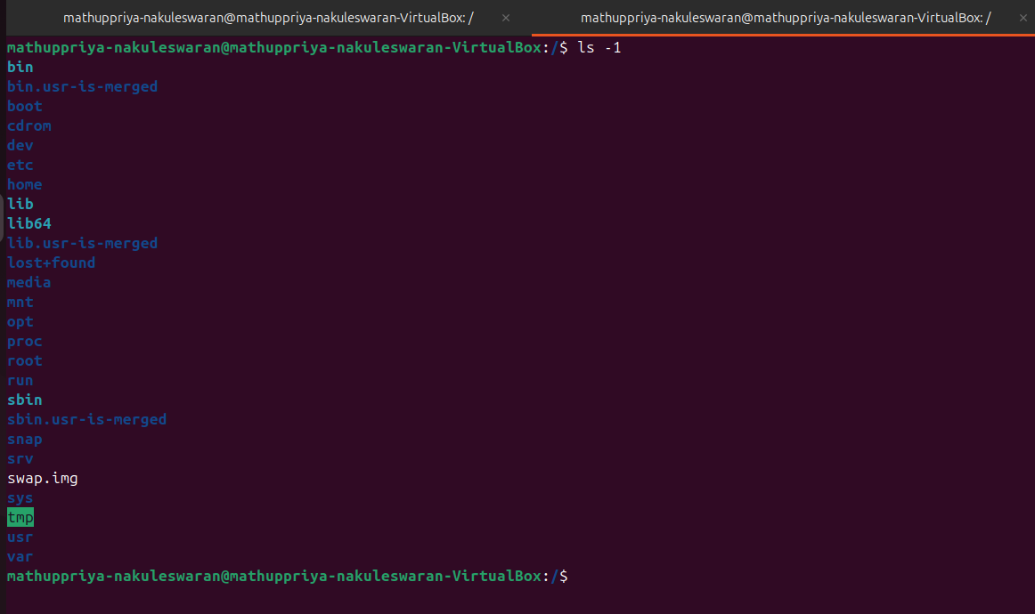
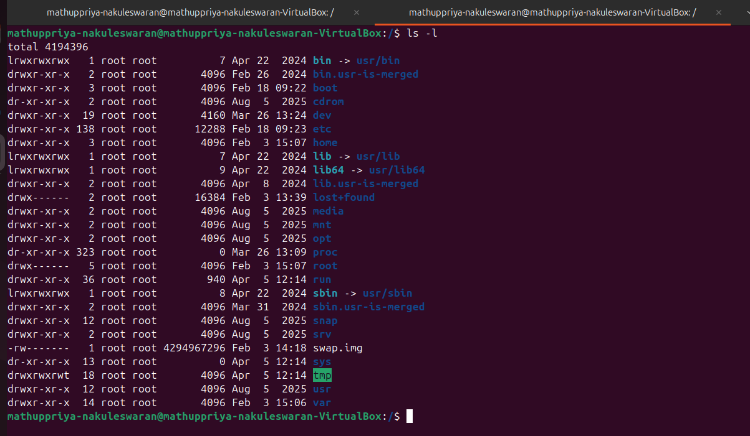
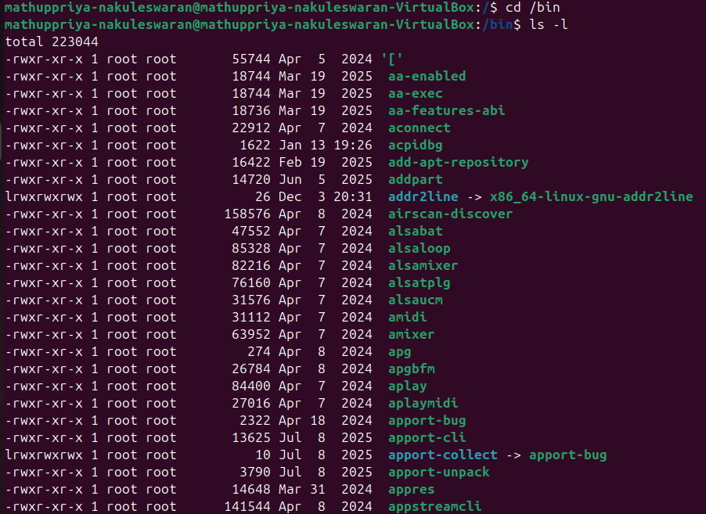
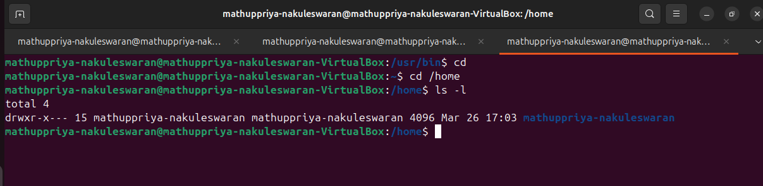
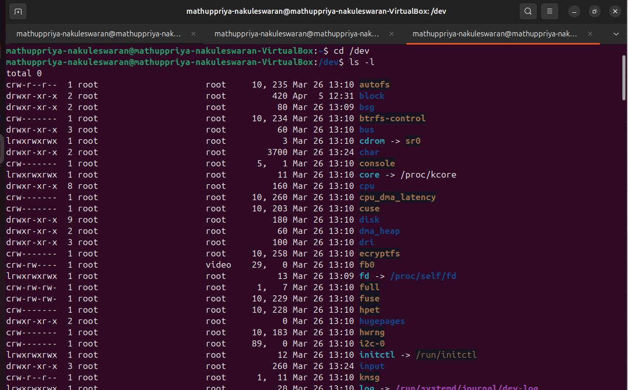
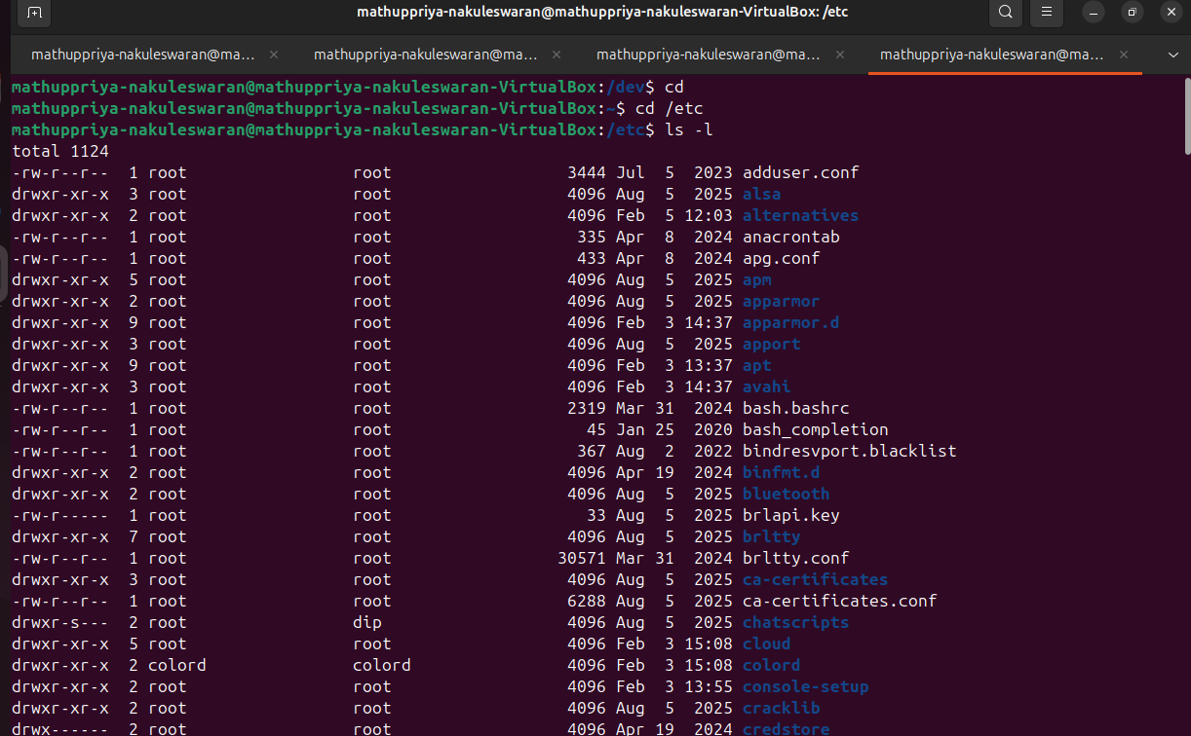
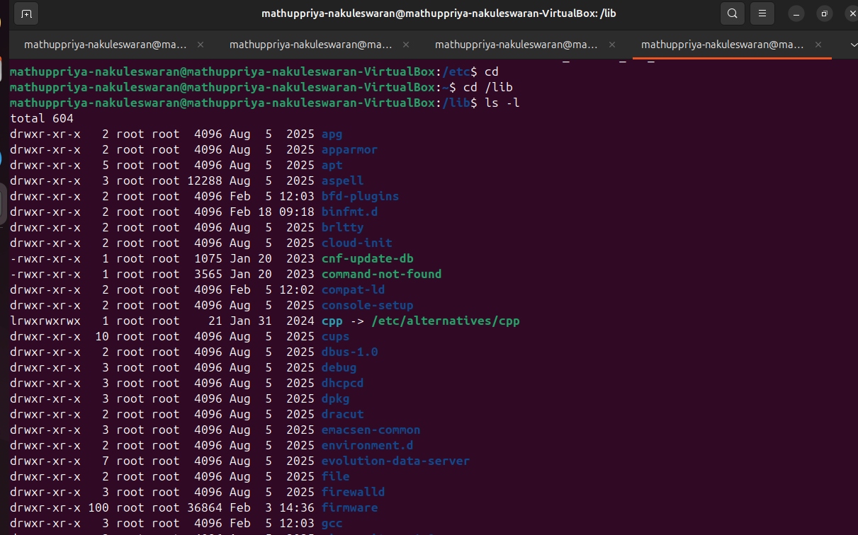
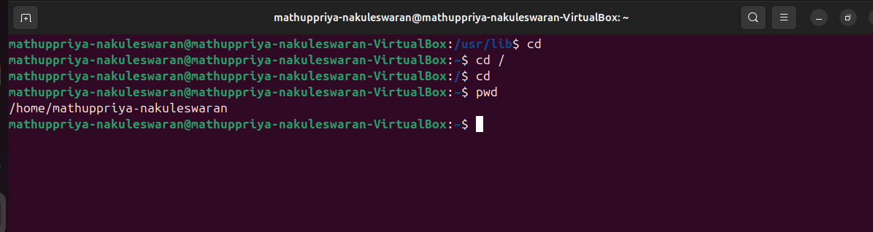
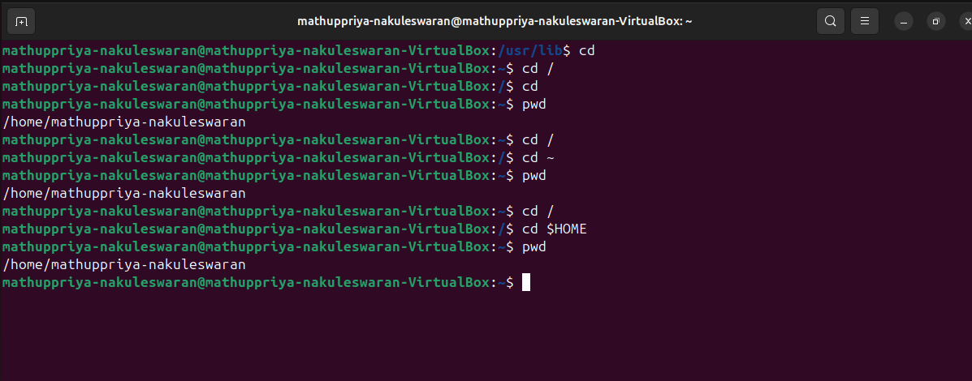
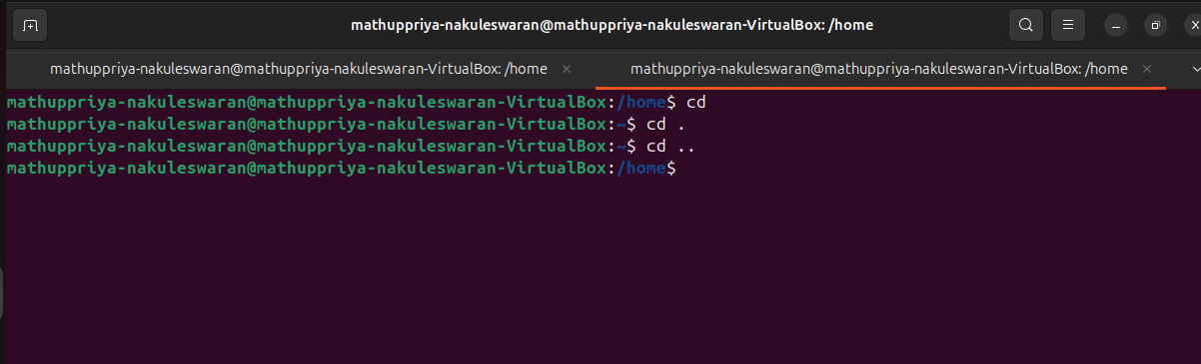
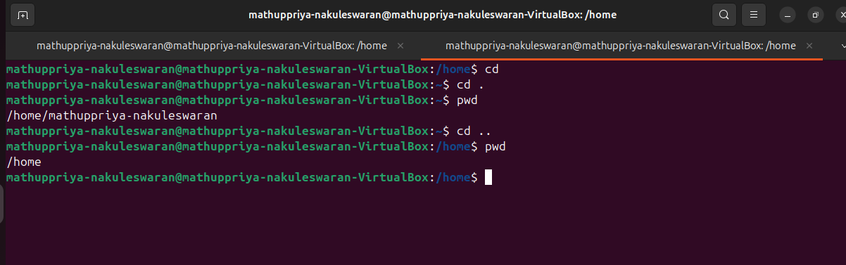

Activity 2 — File Access Permissions
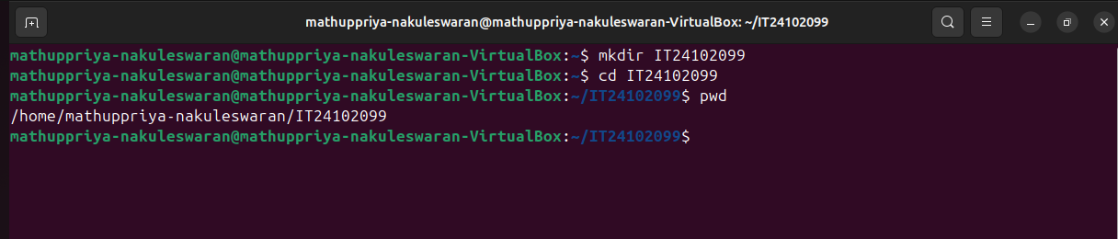
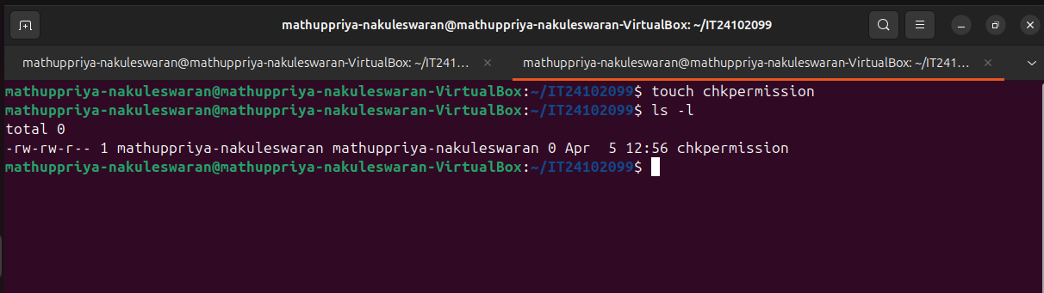
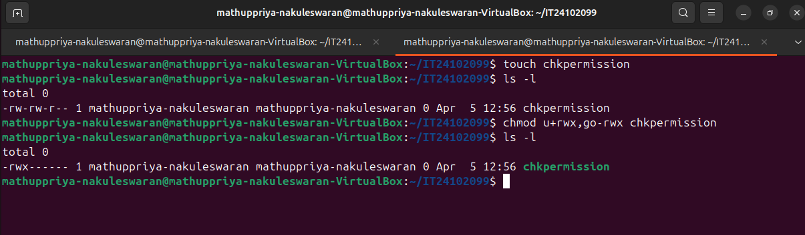
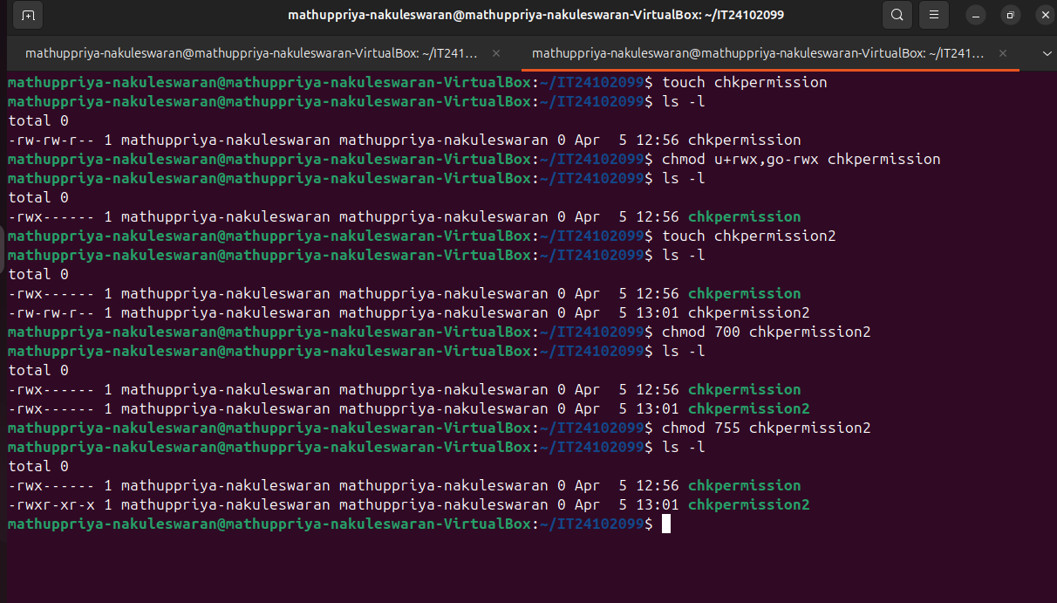
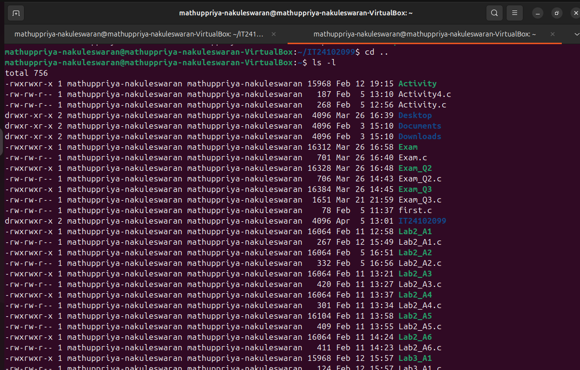
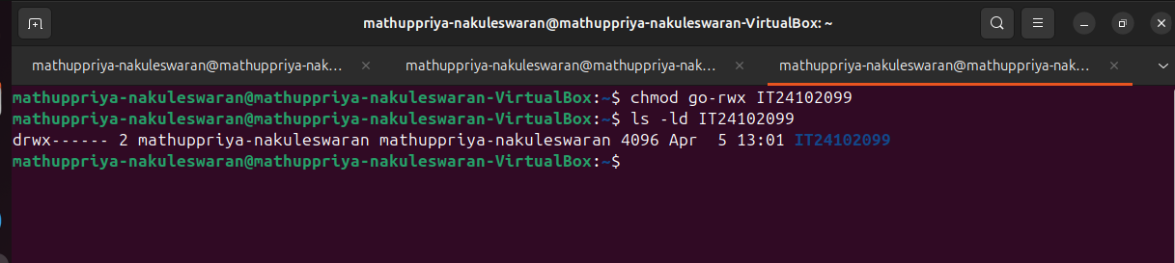
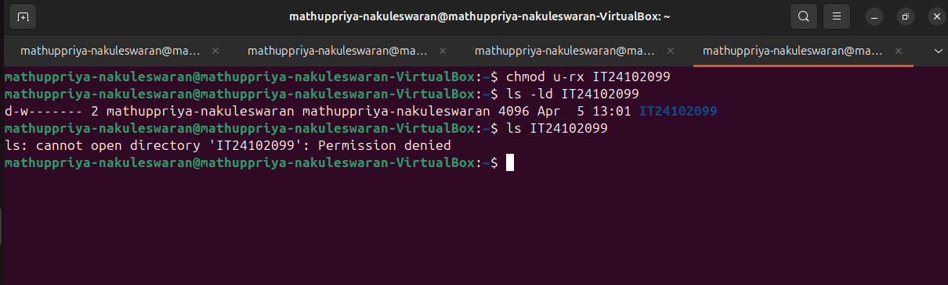
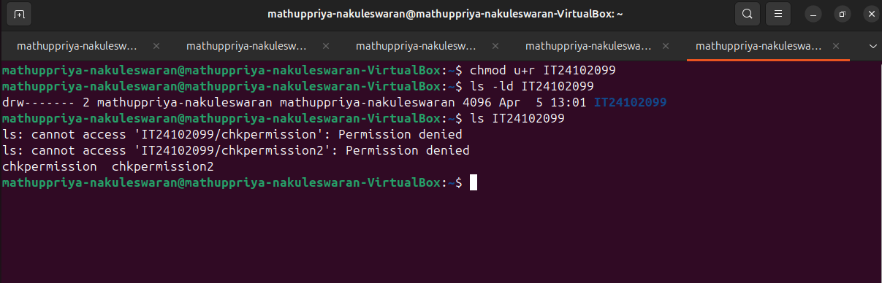
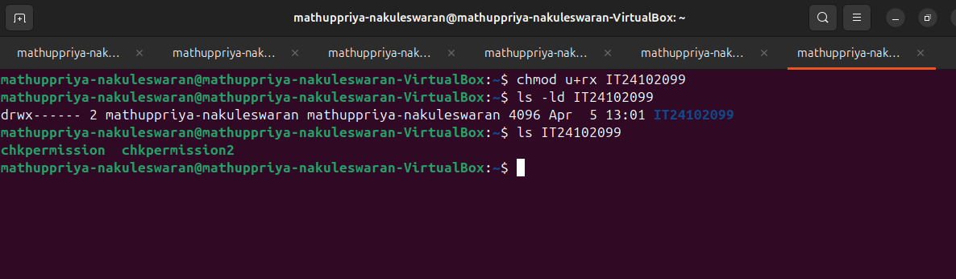
Activity 3 — Changing File/Directory Modes
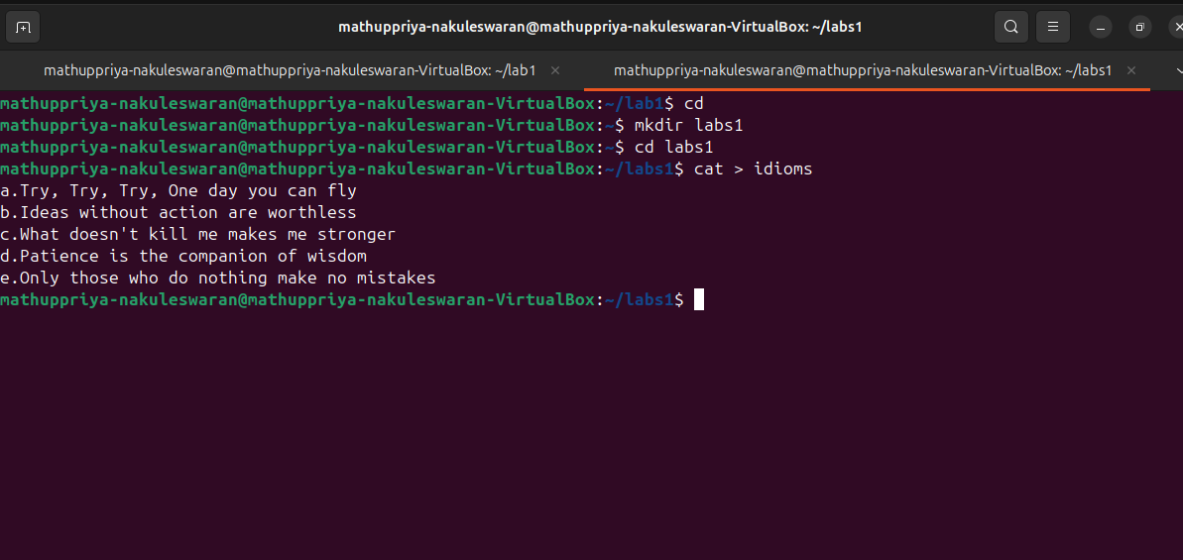
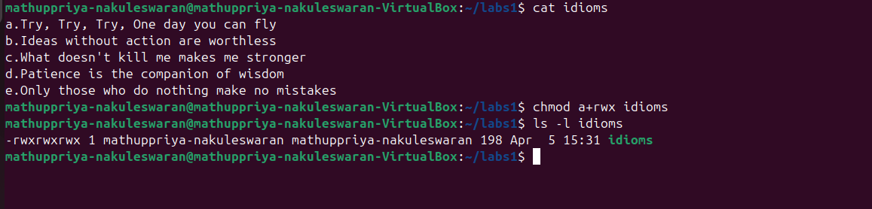
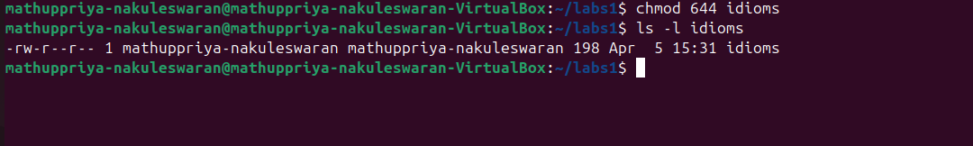
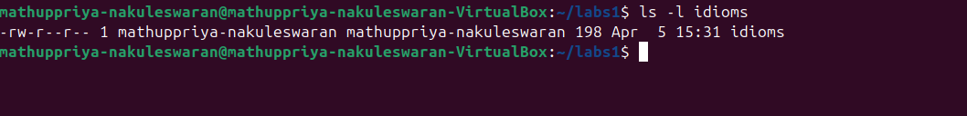
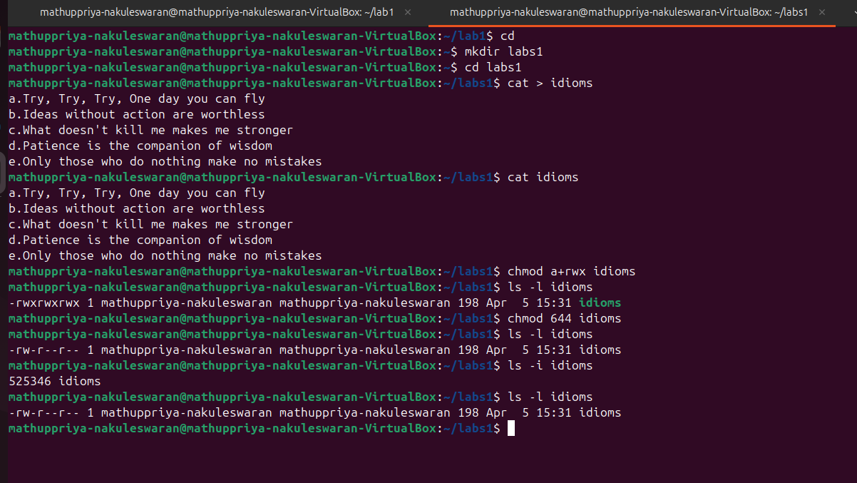
Activity 4 — Hard Links and Soft Links
